VOA Learning English

🎓 Definition
# Source: Windows ScreenShots (using Lightshot Program) From Site -> https://learningenglish.voanews.com/ at [11/13/2025]
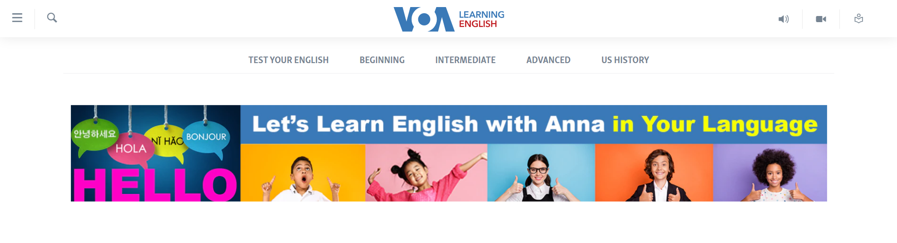
# Source: Chatgpt (GPT-5-Mini) at [11/13/2025]
VOA Learning English — https://learningenglish.voanews.com/ — is a specialized branch of Voice of America focused on teaching and improving English language skills for non-native speakers. Here’s a detailed breakdown:

📌 Overview
# Source: Chatgpt (GPT-5-Mini) at [11/13/2025]
- Part of the Voice of America network, aimed at English learners worldwide.
- Offers simplified news, stories, and educational content using easy-to-understand English.
- Designed for learners of all levels, from beginner to advanced.

⚡ Key Features
# Source: Chatgpt (GPT-5-Mini) at [11/13/2025]
- Slow-paced news broadcasts: Articles and audio read at a slower speed to aid comprehension.
- Vocabulary and grammar support: Key words and phrases explained in context.
- Multimedia content: Audio, video, transcripts, and interactive exercises.
- Learning resources: Lessons, quizzes, and practical exercises to improve reading, listening, and speaking.

✅ Purpose
# Source: Chatgpt (GPT-5-Mini) at [11/13/2025]
- To help non-native speakers learn English while staying informed about current events.
- Combines language education with news and cultural content.

🛡️ Safety & Legality
# Source: Chatgpt (GPT-5-Mini) at [11/13/2025]
- Fully legal and safe.
- Part of the U.S. government-funded VOA, with no malware or pirated content.
- Suitable for educational purposes.

📌 Summary
# Source: Chatgpt (GPT-5-Mini) at [11/13/2025]
VOA Learning English is a reliable, educational platform that combines English language learning with simplified news and multimedia resources. It is safe, legal, and authoritative.

